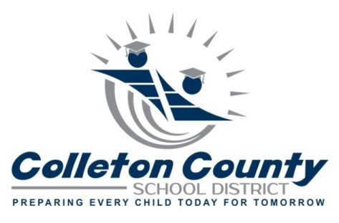
500 Forest Circle
Walterboro, SC 29488
Telephone: 843-782-0022, Facsimile: 843-782-0026
www.colletonsd.org

OFFICE OF EXCEPTIONAL LEARNING

Request Special Education Records

All Requests must be made in writing and include the following:

Date of Request:
Name of Student:
Date of Birth of the Student:

Signature:______________________________________________________
Signature of (Authorization to obtain and/or release records, must be signed by
the holder of education signing rights if the student is less than 18 years old;
otherwise, 18-year-old students must sign and date their own authorization to
obtain release records of information.) the holder of educational signing rights
for the minor.

Form of Identification: An official state or federal form of identification is required with picture of person making the request.

Parents/guardians or eligible (adult)students may request a copy of their records
in writing (mail/fax/email) or in person at the following address:

Office of Exceptional Learning
Attention: Special Education Records Request
500 Forest Circle
Walterboro, SC 29488
Telephone: 843-782-0022
Fax: 843-782-0026

Email: exceptionallearning@colleton.k12.sc.us and jgadsden@colleton.k12.sc.us

